**JECRC**

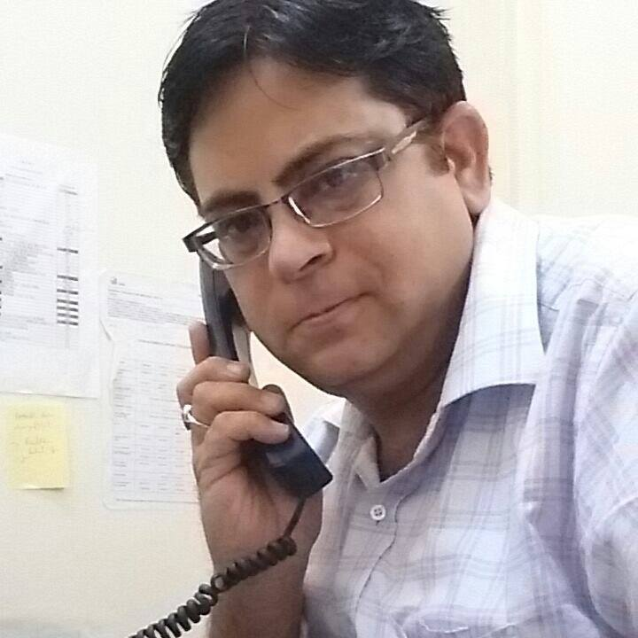

**JAIPUR**

**INDIVIDUAL FACULTY DATA SHEET**

|  |  |  |
| --- | --- | --- |
| **Name of the faculty member** | **:** | SHYAMSUNDER MANAKTALA  ************** |
| **Present Designation** | **:** | ASSISTANT PROFESSOR  **************** |

**Email Id: ssmanaktala.ece@jecrc.ac.in**

**Contact Details: 9251039748**

**I. Particulars of Educational Qualification: (*only completed*)**

|  |  |  |  |  |  |
| --- | --- | --- | --- | --- | --- |
| **Category** | **Name of the Degree** | **Specialization** | **Year of Passing** | **Name of the College** | **Name of the University** |
| **UG** | **B.E.** | **ELECTRONICS** | **1997** | **Y.C.C.E.** | **NAGPUR** |
| **PG** | **M.TECH.** | **VLSI DESIGN** | **2010** | **MNIT JAIPUR** | **MNIT** |
| **PG DEPLOMA** | **PGDASDD** | **C/C++/JAVA/ADVANCE JAVA** | **2000** | **ER&DCI,NOIDA** | **ER&DCI,NOIDA** |
| **Ph.D.** |  |  |  |  |  |

**II. Academic Experience : 16 YEARS**

**III. Industrial Experience :2 YEARS**

**IV. Title of Ph.D. Thesis :**

**V. Awards/Achievements : SCJP/IBM DB2 ASSOCIATE/BEST PROJECT GUIDE/ MERIT COME NEAR SCHOLARSHIP IN SECONDARY RESULT**

**VI. Research/Specialization : NANOTECHNOLOGY FOR SOLID STATE LIGHTENING/ VLSI DESIGN/JAVA PROGRAMMING**

**VII. Course Taught : 1.POC**

**2: DE**

**3: MEMS AND NANOTECHNOLOGY**

**4: CAD FOR VLSI**

**5: VLSI DESIGN**

**6: TEF**

**7: POWER ELECTRONICS**

**8: DMS**

**9: ADBMS**

**10:JAVA PROGRAMMING**

**VIII. Refereed International Journal Publication :**

**IX. International Conference Proceeding**

**:1. RFID and SMART CARD-** International conference on web based learning and library Management

**:2 FUTURE OF NETWORKING IN 5G-RTDEEE2018**

**:3LED FOR SOLID STATE LIGHTENING CHALLENGES AND PERFORMANCE PARAMETERS-RTDEEE2018**

**X. Books Written :**

|  |  |  |  |  |  |  |
| --- | --- | --- | --- | --- | --- | --- |
| S. No. | Author | Title of book | National / International | Name of publisher | ISBN No. | Year of publication |
| 1 | SSMANAKTALA | “Advanced Database Management Systems | National | Ashirwad |  | 2012 |
| 2 | SSMANAKTALA | Distributed Systems Concepts and design | National | Ashirwad | 978-93-80343-62-4 | 2011 |
|  |  |  |  |  |  |  |
| 3 | SSMANAKTALA | “Information Technology | National | CBH |  | 2010 |

**XI. M.Tech Thesis Guide :**

**XII. PHD Thesis Guide :**

**XIII. Professional Body Membership :**